School Fee Payments Interface Specification Low Level Design Document

**EIDIKOSYSTEMS INTEGRATORS**



Version: 1.0

Release Date:11-08-2020

|  |  |  |
| --- | --- | --- |
| Prepared By | Reviewed By | Approved By |
| EIDIKO |  |  |

Document Classification: CONFIDENTIAL

Contents

1 Introduction 5

1.1 General Description 5

2 Purpose 5

3 Scope 5

3.1 In Scope 5

4 Channels Involved 5

5 Interface Dependencies 6

5.1 External Dependencies 6

5.2 Internal Dependencies 6

6 Business Process Summary 7

6.1 Process Overview 7

Figure: 1 Process flow Approach for Currency Converter. 7

6.1.1 Currency Converter Steps 7

7 IIB Implementation Process Flow 8

7.1 Currency Converter Successfull Request Response Flow 8

7.1.1 Process Diagram 8

7.1.2 Process Flow Steps 8

7.2 Retry Process workflow 9

7.2.1 Process Flow Diagram 9

7.2.2 Process Flow steps 9

8 Interface Definitions 14

8.1 Request Message Definition 14

8.1.1 Channel Request Message Structure /Schema 14

8.1.2 Channel Request Message Details 15

8.1.3 Channel Sample Source Messages 15

8.1.4 T24 Request Message Structure /Schema 16

8.1.5 T24 Response Message Details 16

8.1.2 Data Base Response Codes 17

8.2 Response Message Definition 17

8.2.1 T24 Response Message Structure/Schema 17

8.2.2 T24 Response Message Details 17

8.2.3 T24 Sample Response Messages 18

8.2.2 Channel Response Message Details 19

8.2.3 Channel Sample Response Messages 20

9 Logging Mechanism 21

9.3 File Based Logging 23

9.3.1 Log4j 23

**Approval**

|  |  |  |  |  |
| --- | --- | --- | --- | --- |
| Project Role | Approver | Company | E-mail | Sign-Off Date |
|  |  | Eidiko |  |  |
|  |  |  |  |  |
|  |  |  |  |  |
|  |  |  |  |  |
|  |  |  |  |  |
|  |  |  |  |  |
|  |  |  |  |  |

**Revision History**

|  |  |  |  |
| --- | --- | --- | --- |
| Date | Description | Version | Author |
|  |  |  |  |
|  |  |  |  |
|  |  |  |  |
|  |  |  |  |
|  |  |  |  |
|  |  |  |  |

# Introduction

## General Description

This Interface Design document outlines the integration requirements for the School Fee Payment***(Request and Response)***interface used as banking operations. It summarizes the business processes, which use this interface. It also covers error handling and exception scenarios.

# Purpose

The purpose of this document is to capture events that trigger the interface, main steps within the interface and the integration architecture. This document is intended for use by the developers of the applications identified, the integration development team, and by the test organizations responsible for the testing of these applications.

# Scope

## In Scope

This document focuseson outlining the interface design for theSchool Fee Payment***(Request and Response)***interface. Central to this document are the following:

* Overview of the business process that drives the need for the interface
* Proposed integration approach
* Trigger events and business dependencies on this interface
* Sequence /Flow Chart diagram of the interface
* Error handling and exception scenarios
* Validation and backup requirements

# Channels Involved

The following table lists School Fee Paymentschannels

|  |  |
| --- | --- |
| **Item #** | **Channel Name** |
| 1 | *236# |

# Interface Dependencies

## External Dependencies

The following table lists interface specific External requirements.

|  |  |
| --- | --- |
| **Item #** | **External Requirements** |
| 1 | ORADSN DataBase |
| 2 | Core Banking System |

## Internal Dependencies

The following table lists interface specific internal requirements.

|  |  |
| --- | --- |
| **Item #** | **Internal Requirements** |
| 1 | HTTP Router Interface |
| 2 | HTTP Retry Interface |
| 3 | DB Logging App |
|  |  |

# Business Process Summary

## Process Overview

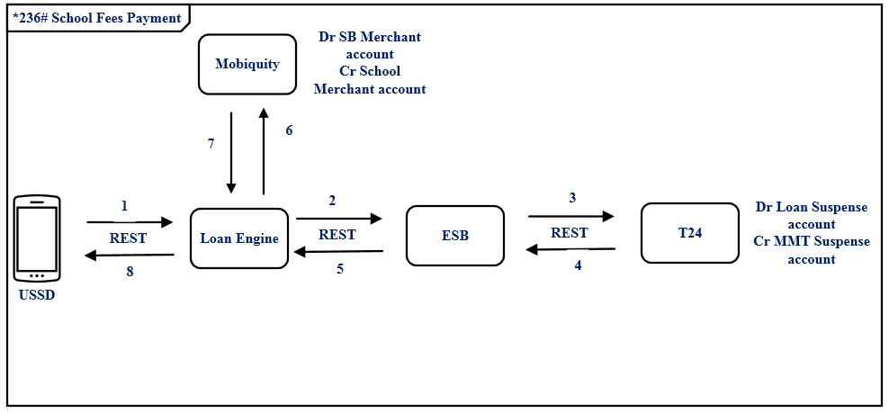

### Figure:1 Process flow Approach for Currency Converter.

### School Fee Payment Steps

|  |  |
| --- | --- |
| **S. No** | **Activities** |
| 1 | ESB receives the request from channel. |
| 2 | Requestchannel is the http request accepts the request from the channel |
| 3 | ESB frames the Request URL According to the T24 requires and send to the T24. |
| 4 | T24 will Respond back to the ESB with Response |
| 5 | The same T24 Response, ESB will send back to the channel. |
| 6 | On Successful call of T24 Response will be placed in theRAW_LOG_SB_REQto logthe response in Data Base(RAW_AUDIT_LOGGING |
| 7 | On Unsuccessful call of T24 Response will beplaced in theERROR_LOG_SB_REQto log the response in Data Base(ERR_AUDIT_LOGGING |

# IIB Implementation Process Flow

## School Fee Payment Successfull Request Response Flow

### Process Diagram

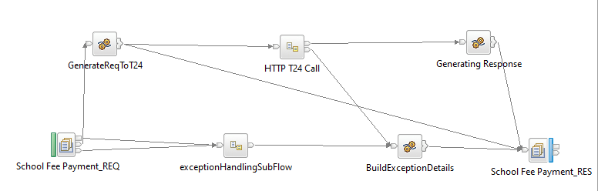

**Figure:2School Fee Payment Flow**

### Process Flow Steps

|  |  |
| --- | --- |
| **S. No** | **Activities** |
| 1. | ESB receives the request from the channel using the HTTP Router Application based on procesingCode& channel trigs the Business Application(SchoolFeePaymentFlow) using Business Queue (SFP_SB_HTTP_REQ) i.e Request from channel. |
| 2 | Initial request and response are logged in the RAW_LOG_SB_REQ and is insert in Data Base(RAW_AUDIT_LOGGING). |
| 3 | After logging of request ESB frames the Request URL to T24 serveri.e T24 server. |
| 4 | After Framing the T24 Request is logged in RAW_LOG_SB_REQ and is insert in Data Base |
| 5 | If the T24 call is successful, then JSON response is generate. |
| 6 | T24 Response in JSON Format is logged in RAW_LOG_SB_REQ and insert in Data Base (RAW_AUDIT_LOGGING) |
| 7 | After the Response is generated by T24 call same response is sending back to Channel with the help of HTTP Router Application. Here ESB frames the Channel Response(T24 Response) |
| 8 | T24 Response is logged in RAW_LOG_SB_REQ and is insert in Data Base(RAW_AUDIT_LOGGING) |
| 9 | On Unsuccessfull calls of T24 Request and Response will be placed in the ERROR_LOG_SB_REQto log the request in Data Base(ERR_AUDIT_LOGGING) |

## Retry Process workflow

### Process Flow Diagram

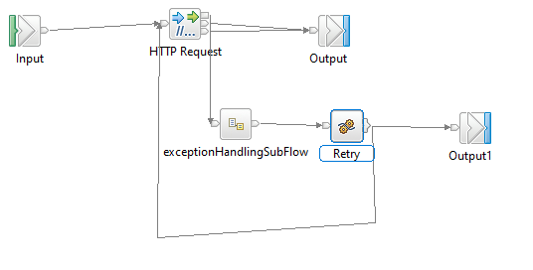

**Figure:3HTTP Retry forCurrency Converter**

### Process Flow steps

|  |  |
| --- | --- |
| **S. No** | **Activities** |
| 1 | HTTP Retry call is used to call the backend service for multiple times |
| 2 | On Successfull call of backend service, response will be generated and send back to Business Application For further process |
| 3 | On Unsuccessfull call of backend service it Retry for 3 times and sends error message to Business Application for further Process |

**7.3Raw_Audit Process Flow:**

**7.3.1Process Flow Diagram:**

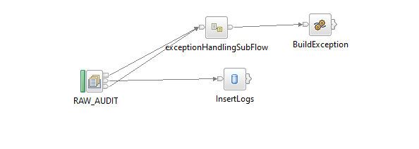

**Figure:4Raw_Audit_Logging Flow**

**7.3.2 Process Flow Steps:**

|  |  |
| --- | --- |
| **S. No** | **Activities** |
|  | The RAW_AUDIT locks the input Request and Response |
|  | After the query is executed the record is inserted into the DataBase. |
|  | Final Response is inserted into the DataBase and then Response is logged into the RAW_LOG_SB_REQ. |

**7.4HTTP Router Process Flow**

**7.4.1 Incoming Router Process Flow Diagram:**

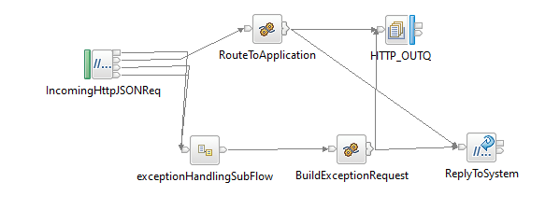

**Figure:5Incoming Router Flow**

**7.4.2 Process Flow Steps:**

|  |  |
| --- | --- |
| **S. No** | IIB receives the request from channel. |
|  | ESB receives the request from channel. |
|  | Requestchannel is the http request accepts the request from the channel |
|  | The request message is placed in theRAW_LOG_SB_REQto log the request in Data Base(RAW_AUDIT_LOGGING) |
|  | According to the Channel Request message fields such as channel and processing code it picks the queue name of the business flow from INTEGRATION_SOL_DETAILS table and propagates it to the business flow. |
|  | It validates the processingCode, Channel and domain of input from INTEGRATION_SOL_DETAILS if it fails to validate the error response is logged in the logs and in Data Base (ERROR_AUDIT_LOG) |
|  | After the validation Request message is passed through ESB. If the queue name presents in MQ manager the ESB business flow triggers otherwise the error response is sent to the front end as Unable to open queue. |
|  | If it is success or failure response will store them in RAW_AUDIT_LOG table or ERROR_AUDIT_LOG and logging into log file. |
|  | The request from channel is sent to ESB CurrencyConverter Flow |

**7.4.3 Integration Solution Details**

**Table Name: INTEGRATION_SOL_DETAILS**

|  |  |  |  |  |  |  |
| --- | --- | --- | --- | --- | --- | --- |
| **Item #** | **DB Field Name** | **Field Description** | **Data Type** | **Length** | **Mandatory(Yes/No)** | **Comments** |
| 1 | PROC_CODE | Processing Code | Varchar | 20 | Y | From input request |
| 2 | REQ_QUEUE | TCPIP Request Queue | Varchar | 20 | N | This Request Queue Name field is used for ISO Related Application |
| 3 | RES_QUEUE | TCPIP Response Queue | Varchar | 20 | N | This Response Queue Name field is used for ISO Related Application |
| 4 | HTTP_REQ | HTTP Request Queue | Varchar | 20 | Y | This Request Queue Name field is used for REST Related Application |
| 5 | HTTP_RES | HTTP Response Queue | Varchar | 20 | Y | This Response Queue Name field is used for REST Related Application |
| 6 | CHANNEL | Channel | Varchar | 20 | Y | Channel Name |
| 7 | MSGDOMAIN | Message Domain | Varchar | 20 | Y | Request Message Format |

**7.4.4 Outgoing Router Process Flow Diagram**

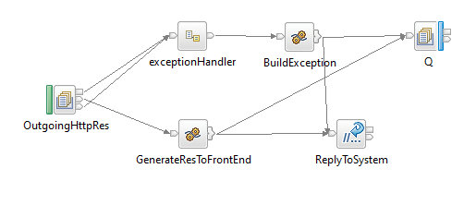

**Figure:6Outgoing Router Flow**

**7.4.5 Process Flow Steps:**

|  |  |
| --- | --- |
| **S. No** | **Activities** |
|  | TheOutgoingHttpRes brings the Channel Response |
|  | Channel Response will be logged in RAW_LOG_SB_REQ and insert in Data Base. |
|  | Finally Channel Response will be send to the Front End. |

**7.5Error_Audit Process Flow**

**7.5.1 Process Flow Diagram:**

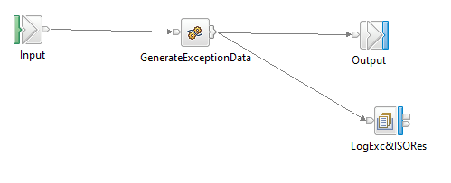

**Figure:7Exception Subflow**

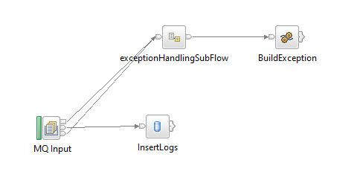

**Figure:8Error_Audit_Logging Flow**

**7.5.2 Process Flow Steps:**

|  |  |
| --- | --- |
| **S. No** | **Activities** |
|  | The ERROR_AUDIT_Q locks the input Request. |
|  | After the query is executed the record is inserted into the Data Base. |
|  | Final Response is inserted into the DataBase and then Response is logged into the ERR_LOG_SB_REQ. |

# Interface Definitions

## Request Message Definition

### ChannelRequest Message Structure /Schema

**Request Type:** HTTP

**Request Format:**JSON

**Request URL:**<http://IPAddress:Port/v1/stewardBank/>

### 8.1.2 ChannelRequest Message Details

|  |  |  |  |  |
| --- | --- | --- | --- | --- |
| **Item #** | **Tag Name/ Field Name** | **Data Type** | **Mandatory(Yes/No)** | **Comments** |
| 1 | processingCode | String | Y | Processing Code |
| 2 | creditAccountNumber | String | Y | Credit Card Number |
| 3 | debitAccountNumber | String | Y | Debit Card Number |
| 4 | debitAmount | String | Y | Amount to Debit |
| 5 | mobileNumber | String | Y | Mobile Number |
| 6 | debitCurrency | String | Y | Debit Currency |
| 7 | transactionType | String | Y | Type of Transaction |
| 8 | debitReference | String | Y | Debit Reference |
| 9 | paymentDetails | String | Y | Details of Payments |
| 10 | Channel | String | Y | Channel Name |
| 11 | Biller | String | Y | Biller |

### 8.1.3 Channel Sample Source Messages

|  |
| --- |
| {  "processingCode":"180000",  "creditAccountNumber":"1000000163",  "debitAccountNumber":"1000000578",  "debitAmount":"89.09",  "mobileNumber":"9126324299",  "debitCurrency":"ZWL",  "transactionType":"26324299",  "debitReference":"BusinessCurrent",  "paymentDetails":"AUTWLD",  "channel":"*236#",  "biller":"Implementation"  } |

### 8.1.4 T24 Request Message Structure /Schema

**Request Type:** HTTP

**Request Format:**JSON

**RequestURL:**http://192.168.1.233:8080/stwbc/api/v1.0.0/stwb/payment/schoolFees/{debitAccount}/{debitCurrency}/{transactionAmount}/{executionDate}/{customer}

### 8.1.5 T24 Response Message Details

|  |  |  |  |  |
| --- | --- | --- | --- | --- |
| **Item #** | **Tag Name/ Field Name** | **Data Type** | **Mandatory(Yes/No)** | **Comments** |
| 1 | debitAccount | String | Y | Debit Account |
| 2 | debitCurrency | String | Y | Debit Currency |
| 3 | transactionAmount | String | Y | Transaction Amount |
| 3 | executionDate | String | Y | Date of Execution |
| 2 | Customer | String | Y | Customer |

### 8.1.6 Data Base Response Codes

001 = "Fatal Exception";

002 = "Recoverable Exception";

003 = "Configuration Exception";

004 = "Security Exception";

005 = "Parser Exception";

006 = "Conversion Exception";

007 = "Data Base Exception";

008 = "User Exception";

009 = "Cast Exception";

010 = "Message Exception";

011 = "SQL Exception";

012 = "Socket Exception";

013 = "Socket Timeout Exception";

014 = "Unknown Exception";

015 = "Failure";

## Response Message Definition

### T24Response Message Structure/Schema

**Response Type:**JSON

### T24 Response Message Details

|  |  |  |  |  |
| --- | --- | --- | --- | --- |
| **Item #** | **Tag Name/Field Name** | **Data Type** | **Mandatory(Yes/No)** | **Comments** |
| 8 | Header | String | Y | Header Tag |
| 9 | transactionStatus | String | Y | Transaction Status |
| 10 | Audit | String | Y | Audit |
| 11 | T24_time | String | Y | T24 Time |
| 12 | parse_time | TimeStamp | Y | Parse Time |
| 13 | responseParse_time | TimeStamp | Y | Response Parse Time |
| 14 | requestParse_time | TimeStamp | Y | Request Parse Time |
| 15 | versionNumber | String | Y | Version Number |
| 16 | Id | String | Y | Id |
| 17 | Status | String | Y | Status |
| 18 | Body |  | Y | Body Tag |
| 19 | chargeBearer | String | Y | Bearer Charge |
| 20 | orderingCustomerId | String | Y | Ordering Customer Id |
| 21 | debitCurrency | String | Y | Debit Currency |
| 22 | transactionAmount | Integer | Y | Transaction Amount |
| 23 | endToEndReference | String | Y | End to End Reference |
| 24 | executionDate | TimeStamp | Y | Execution Date |
| 24 | debitAccountId | String | Y | Debit Account Id |
| 25 | orderingCustomerName | String | Y | Ordering Customer Name |
| 26 | creditAccountId | String | Y | Credit Account Id |
| 27 | paymentCurrency | String | Y | Payment Currency |
| 28 | paymentOrderProductId | String | Y | Payment Order Product Id |

### 8.2.3 T24 Sample Response Messages

|  |
| --- |
| {  "header": {  "transactionStatus": "Live",  "audit": {  "T24_time": 320,  "parse_time": 1,  "responseParse_time": 2,  "requestParse_time": 2,  "versionNumber": "1"  },  "id": "PI2022803SW1QC4Z",  "status": "success"  },  "body": {  "chargeBearer": "OUR",  "orderingCustomerId": "100142",  "debitCurrency": "ZWL",  "transactionAmount": 89.09,  "endToEndReference": "NOTPROVIDED",  "executionDate": "20200818",  "debitAccountId": "1000000578",  "orderingCustomerName": "BusinessCurrent",  "creditAccountId": "ZWL1409200010004",  "paymentCurrency": "ZWL",  "paymentOrderProductId": "SCHOOLFEES"  }  } |

### 8.2.2ChannelResponse Message Details

|  |  |  |  |  |
| --- | --- | --- | --- | --- |
| **Item #** | **Tag Name/Field Name** | **Data Type** | **Mandatory(Yes/No)** | **Comments** |
| 1 | SchoolFeePayment | String | Y | Main Tag |
| 2 | Header | String | Y | Header Tag |
| 3 | Channel | String | Y | Channel Name |
| 4 | processingCode | String | Y | Processing Code |
| 9 | transactionStatus | String | Y | Transaction Status |
| 10 | Audit | String | Y | Audit |
| 11 | T24_time | String | Y | T24 Time |
| 12 | parse_time | TimeStamp | Y | Parse Time |
| 13 | responseParse_time | TimeStamp | Y | Response Parse Time |
| 14 | requestParse_time | TimeStamp | Y | Request Parse Time |
| 15 | versionNumber | String | Y | Version Number |
| 16 | Id | String | Y | Id |
| 17 | Status | String | Y | Status |
| 18 | Body |  | Y | Body Tag |
| 19 | chargeBearer | String | Y | Bearer Charge |
| 20 | orderingCustomerId | String | Y | Ordering Customer Id |
| 21 | debitCurrency | String | Y | Debit Currency |
| 22 | transactionAmount | Integer | Y | Transaction Amount |
| 23 | endToEndReference | String | Y | End to End Reference |
| 24 | executionDate | TimeStamp | Y | Execution Date |
| 24 | debitAccountId | String | Y | Debit Account Id |
| 25 | orderingCustomerName | String | Y | Ordering Customer Name |
| 26 | creditAccountId | String | Y | Credit Account Id |
| 27 | paymentCurrency | String | Y | Payment Currency |
| 28 | paymentOrderProductId | String | Y | Payment Order Product Id |

### 8.2.3ChannelSample Response Messages

|  |
| --- |
| {  "SchoolFeePayment": {  "header": {  "channel": "*236#",  "processingCode": "180000",  "responseCode": "200"  "transactionStatus": "Live",  "audit": {  "T24_time": 472,  "parse_time": 2,  "responseParse_time": 2,  "requestParse_time": 2,  "versionNumber": "1"  },  "id": "PI202270XYCNN8GQ",  "status": "success"  },  "body": {  "chargeBearer": "OUR",  "orderingCustomerId": "100142",  "debitCurrency": "ZWL",  "transactionAmount": 89.09,  "endToEndReference": "NOTPROVIDED",  "executionDate": "20200814",  "debitAccountId": "1000000578",  "orderingCustomerName": "BusinessCurrent",  "creditAccountId": "ZWL1409200010004",  "paymentCurrency": "ZWL",  "paymentOrderProductId": "SCHOOLFEES"  }  }  } |

# Logging Mechanism

**9.1 Insert intoRaw_Audit_Table**

**Table Name:RAW_AUDIT_TABLE**

|  |  |  |  |  |  |  |
| --- | --- | --- | --- | --- | --- | --- |
| **Item #** | **DB Field Name** | **Field Description** | **Data Type** | **Length** | **Mandatory(Yes/No)** | **Comments** |
| 1 | MSGID | MessageID | Varchar | 100 | Y | From input request |
| 2 | LOGGING_TIME | Logging Time | TimeStamp | 6 | Y | Name |
| 3 | MESSAGE | Message(Request/Response) | Clob | - | Y | Request from channel |
| 4 | MESSAGETYPE | Type of Message(Request/Response) | Varchar | 100 | Y | Type of message either Request or Response |
| 5 | APPNAME | Application Name | Varchar | 100 | Y | Name of the Application |
| 6 | BROKER | Broker Name | Varchar | 100 | Y | Broker Name |
| 7 | TIME_LOCAL_TRANSACTION | Transaction Time | Varchar | 20 | Y | Time of the Transaction |
| 8 | DATE_LOCAL_TRANSACTION | Transaction Date | Varchar | 20 | Y | Date of the Transaction |
| 9 | RETRIEVAL_REFERENCE_N | Retrieval Reference Number | Varchar | 20 | Y |  |

**9.2 Insert intoError_Audit_Table**

**Table Name: ERROR_AUDIT_TABLE**

|  |  |  |  |  |  |  |
| --- | --- | --- | --- | --- | --- | --- |
| **Item #** | **DB Field Name** | **Field Description** | **Data Type** | **Length** | **Mandatory(Yes/No)** | **Comments** |
| 1 | MSGID | MessageID | Varchar | 50 | Y | From input request |
| 2 | LOGGING_TIME | Application Name | Timestamp | 50 | Y | Time of the logging |
| 3 | MESSAGE | Message Type(Request/Response) | Clob | 50 | Y | Request of the Message |
| 4 | MESSAGETYPE | Message Type | Varchar | 50 | Y | Type of message either Request or Response |
| 5 | APPNAME | Application Name | Varchar | 4000 | Y | Name of the Application |
| 6 | BROKER | Broker Name | Varchar | - | Y | Name of the Broker |
| 7 | ERRORDESCRIPTION | Exception | Clob | 4000 | Y | Exception Information |
|  | TIME_LOCAL_TRANSACTION | Transaction Time | Varchar | 20 | Y | Time of the Transaction |
|  | DATE_LOCAL_TRANSACTION | Transaction Date | Varchar | 20 | Y | Date of the Transaction |
|  | RETRIEVAL_REFERENCE_NUMBER | Retrieval Reference Number | Varchar | 20 | Y | Retrieval Reference Number |
|  | BORKER_ERROR_CODE | Broker Error Code | Varchar |  | Y | Error code generate by Broker |
|  | USER_DEFINE_ERROR_CODE | User Defined Error Code | Varchar |  | Y | User Defined Code |

## 9.3 File Based Logging

### 9.3.1 Log4j

As part of auditing the request we have to use Log4j mechanism in the application to log the request in the file.

File Path: To be specified, while deploying the application